CAS PY 106

Prelecture Note 22

1. Waves
2. Wave is a disturbance that carries energy from one place to another
3. Classifying Waves
4. Mechanical waves – water waves, sound waves, and waves on strings. The wave requires a medium through which to travel, but there is no net flow of mass though the medium, only a flow of energy
5. Electromagnetic Waves – light, x-rays, microwaves, radio waves, etc. They’re just different frequency ranges of the same kind of wave, and they don’t need a medium
6. Matter Waves – waves associated with things like electrons, protons, and other tiny particles
7. Another way to classify waves
8. Transverse wave: particles in the medium oscillate in a direction perpendicular to the way the wave is travelling. A good example is a wave on a string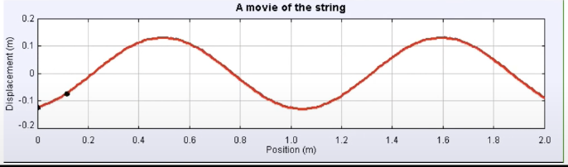
9. Longitudinal wave: the particles in the medium oscillate along the same direction as the way the wave is traveling (parallel to the way the wave is traveling). Sound waves are longitudinal waves

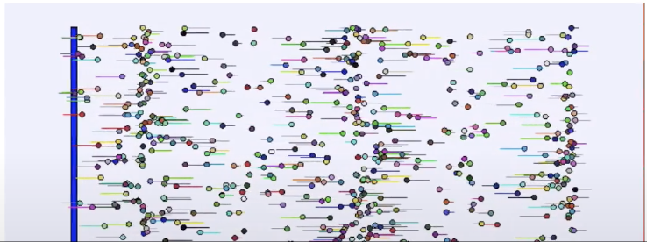

1. Features of waves
2. Frequency (f), measured in hertz(Hz) is how many oscillations each particle of the medium undergoes every second
3. Period (T) is the time for one complete oscillation

T = 1/f

1. The wave speed (v), which is how fast the wave travels through the medium, is determined by properties of the medium. For wave on a string, the wave speed is the square root of the tension divided by the string’s mass per unit length

V = (FT/(m/L))^.5

1. Wavelength (lambda), which is the distance from one peak to the next, is determined by frequency and wave speed

Lambda = v/f = vT

1. Connection with Simple harmonic motion
2. Consider a single-frequency transverse wave. Each particle experiences simple harmonic motion in the y-direction. The motion of any particle is given by:

y(t) = A\*sin(wt + O)

A 🡪 Amplitude

W 🡪 angular frequency 🡪 2pi\*f (frequency)

O 🡪 Phase

1. Describing the motion
2. Each particle oscillates with the same amplitude and frequency, but with its own phase angle. For a wave traveling right, particles to the right lag behind particles to the left. The phase difference is proportional to the distance between the particles.
3. If we say the motion of the particle at x = 0 is given by: y(0,t) = A\*sin(wt)
4. The motion of a particle at another x-value is: y(x,t) = A\*sin(wt-kx) where k is a constant known as the wave number (k is not spring constant)
5. To summarize, the motion of the entire string is given by:

y(x,t) = A\*sin(wt +- kx) 🡪 + for going left, - for going right

1. What is this k thing, anway?
2. A particle distance of 1 wavelength away from another particle would have a phase difference of 2pi

kx = 2pi when x = lambda, so the wave number is k = 2pi/lambda

In other words, wavelength (lambda) = 2pi/k

1. The wave number is related to wavelength the same way the angular frequency is related to the period

W = 2pi/T (where T is the period)

1. Wavelength and period
2. The top picture is a photograph of a wave on a string at a particular instant
3. The graph underneath is a plot of the displacement as a function of time for a single point on the wave
4. 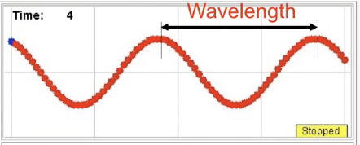
5. 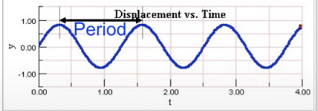
6. Example question
7. 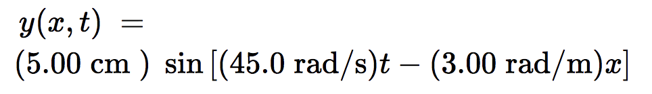
8. Amplitude = 5cm
9. Wavelength:

kx = 2pi where x = wavelength(lambda)

Lambda = 2pi/k = 2pi/3 = 2.09

1. Period of wave:

w = 2pi/T

T = 2pi/w = 2pi/45 = 0.14

1. Relationship between Equations
2. Wavelength
3. Lambda = 2pi/k 🡪 wavelength is affected by k
4. Lambda = v/f = vT 🡪 wavelength is affected by frequency and period
5. Amplitude has no effect on the wavelength
6. V = (FT/(m/L))^.5
7. Lambda = (FT/(m/L))^.5 / f 🡪 wavelength is affected by tension on string and m/L ratio (mass per unit length ratio)
8. Wave speed
9. V = (FT/(m/L))^.5 🡪 velocity is affected by tension on string and m/L ratio (mass per unit length ratio)
10. V = Lambda/T = Lambda\*frequency
11. Amplitude has no effect on the wave speed
12. Frequency and period has no effect on the wave speed
13. Maximum traverse speed 🡪 Amplitude \* angular frequency = amplitude \* w = amplitude \* 2pi \* f (frequency)